Buckland Historical Society, Inc.
PO BOX 88
BUCKLAND, MASSACHUSETTS 01338

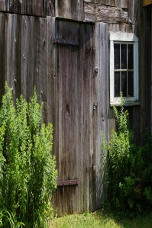
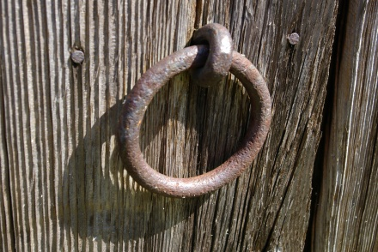
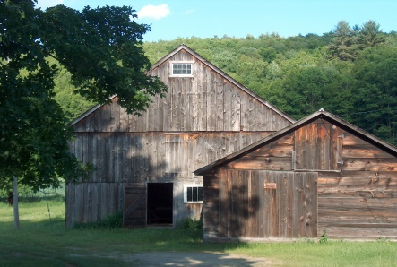

Buckland’s Wilder Homestead Barn Restoration
Capital Campaign

Beautiful 8-Minute 2022 Project video https://vimeo.com/591119932

Total Project Cost Estimate $450,000.00 (+ 10%) $495,000.00
Mass Cultural Facilities Grant Match - $180,000.00
Balance needed from Gifts & Grants $315,000.00

DONOR LEVELS
$100,000.00 Weaving Room
$75,000.00 Ridge Beam $500.00 Rafter
$25,000.00 Girt Beam $250.00 Mortise & Tenon
$10,000.00 Gunstock Post $100.00 Threshing Floor Plank
$5,000.00 Truss $50.00 Trunnel Peg
$1,000.00 Floor Joist $25.00 Forged Nail

Name(s)______________________________________________________________________________

Company_____________________________________________________________________________

Address______________________________________________________________________________

Please list this donation as from “_________________________________________________________”

Email_________________________________________________________________________________

Phone & Extension_______________________________________________________________________

We thank you for your check payable to the Buckland Historical Society $________________________

The Buckland Historical Society is a nonprofit 501(c) (3).

